Corner and edge detector finds intensity for displacement in all directions

Function is maximized, See advanced multivariable calculus and linear algebra textbooks or websites for a true understanding of whats going on

Boils down to finding two eigen values for a matrix m, if either is greater or less than the other outside of a certain order or bound of error(intensity increases greatly in one direction, an edge), than an edge is found within the window. If both eigen values are “large”(increase in intensity in multiple directions, a corner) and close enough to each other within a certain order of error, than a corner is found

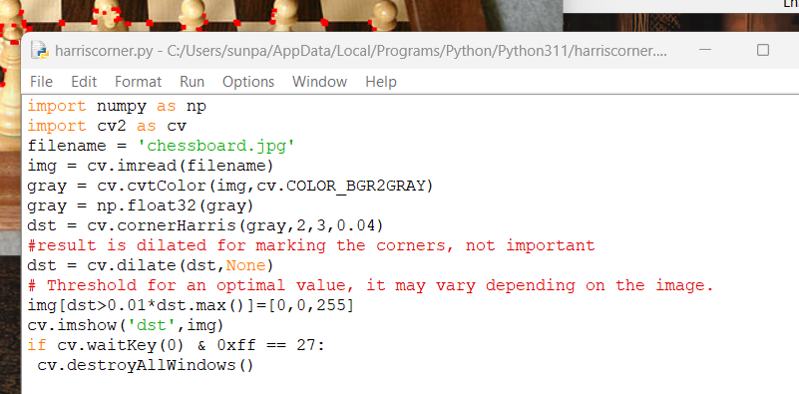

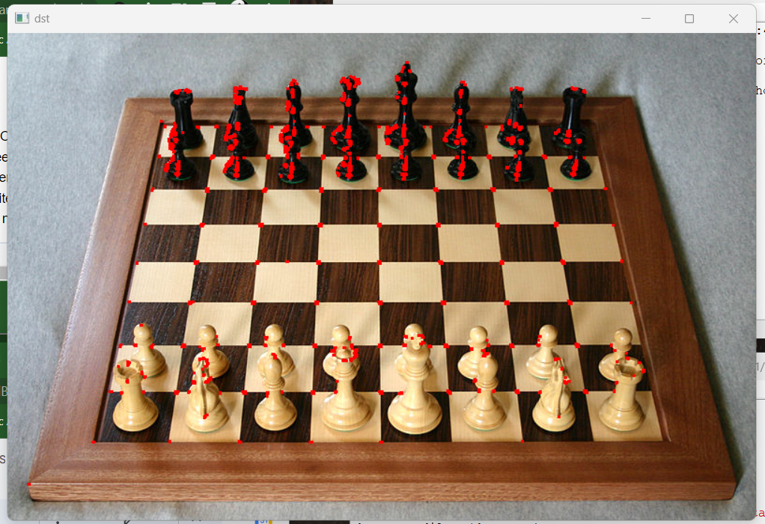

Used a chessboard off the internet to see how it works with clear corners and more vague or less clear corners in everyday pictures, detects squares on board well, detects sharp corners well, however it doesnt detect the corners on the physical wooden edges of the board

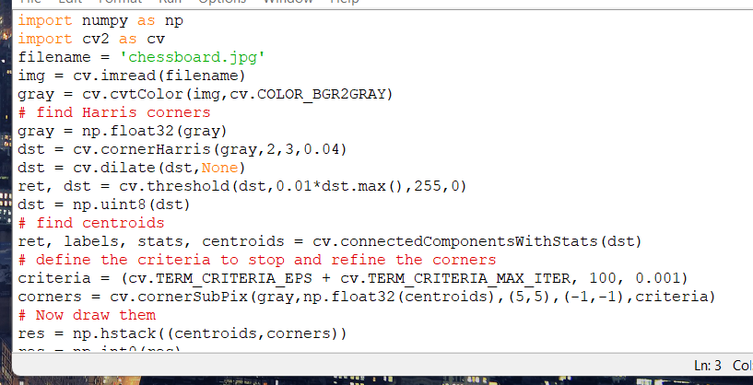

Open cv also has cv.cornerSubPix() for further accuracy using found corners and their centroids as input

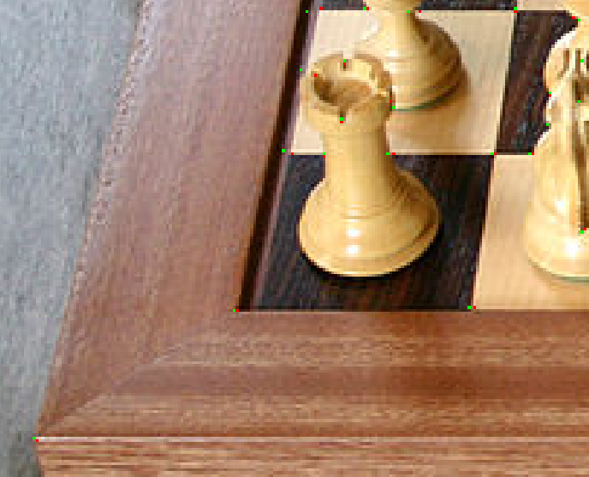

Corners are much more precise and require zooming in to see the single pixel